How to connect to gpu server from home using mobaXterm
By: Pavel Rastopchin.
- Install MobaXterm and start a new session.
- Select type of session: SSH
- Go to “Network settings”
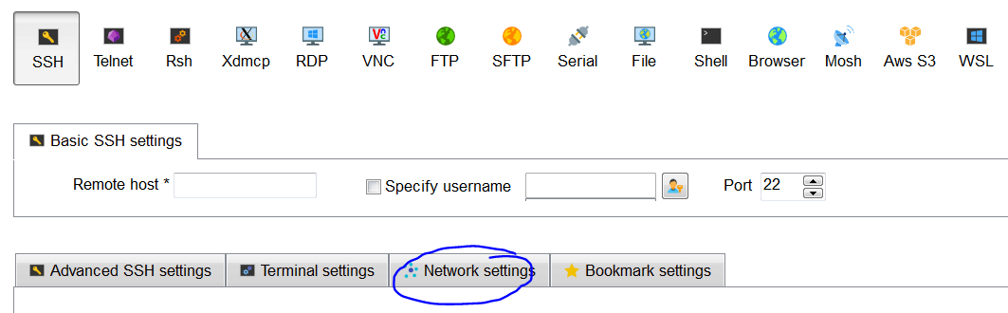

- Use: csl3.cs.technion.ac.il (or other cs server you have access to) as jump host
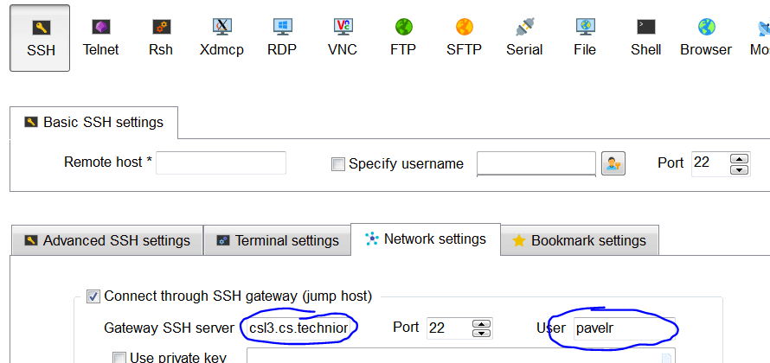
- Now define the IP of course server.
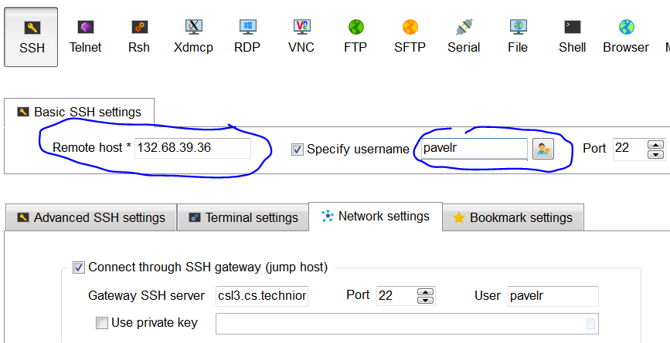
- press ok
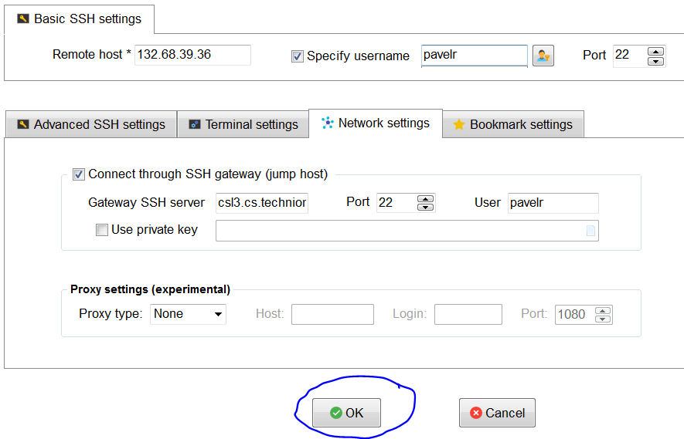
- You should see the terminal and file system:
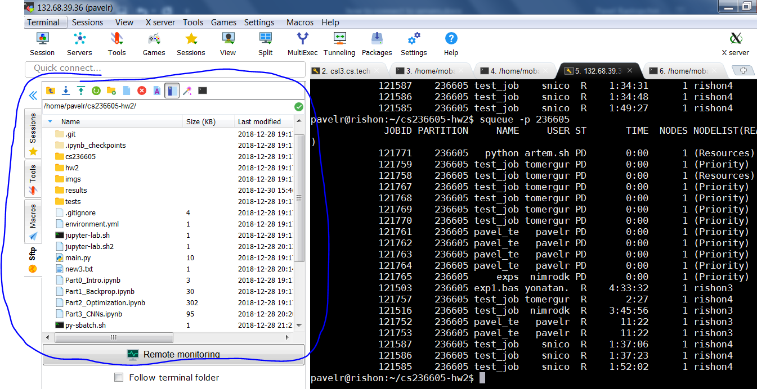
- You should be able to transfer files using those:
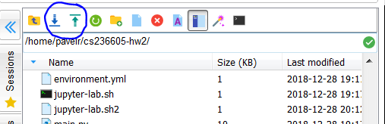
- And edit files directly on the server:
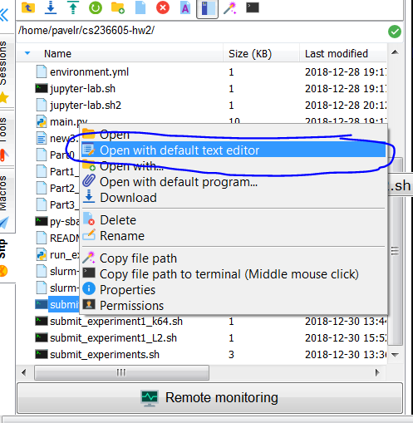
- Tip: “Enable Follow terminal folder”, do “cd <somewhere>” in terminal and be happy.
